Self-Assessment: How Well Do You Recognize and Regulate Emotions?

Sources: Copyright © 2011 Steven L McShane. This self-assessment was inspired by similar instruments, particularly: N. S. Schutte, et al, "Development and validation of a measure of emotional intelligence", Personality and Individual Differences 25, no. 2 (1998): 167–177; C-S Wong and K. S. Law, "The effects of leader and follower emotional intelligence on performance and attitude: An exploratory study", Leadership Quarterly 13 (2002): 243–274; P. J. Jordan, and S. A. Lawrence, "Emotional intelligence in teams: Development and initial validation of the short version of the Workgroup Emotional Intelligence Profile (WEIP-S)", Journal of Management & Organization 15 (2009): 452–469.

Purpose: This self-assessment is designed to help you understand the meaning and dimensions of emotional intelligence and to estimate your perceptions of your emotional intelligence.

Overview: Emotional intelligence has become an important concept and ability in the workplace. It is a skill that people develop throughout their lives to help them interact better with others, make better decisions, and manage the attitudes and behavior of other people. Although emotional intelligence is best measured as an ability test, this scale offers you an opportunity to estimate your perceptions and self-awareness of this ability in yourself.

Instructions: Read each of the statements below and select the response that best describes you. This self-assessment is completed alone so that students rate themselves honestly without concerns of social comparison. However, class discussion will focus on the meaning and dimensions of emotional intelligence, its application in the workplace, and the best ways to measure emotional intelligence.

MY RESULTS
Self-awareness of emotions
Score : 17 pts.
16-20Feedback : This scale measures the four dimensions of emotional intelligence described in this book. Scores on the four Emotional Intelligence Self-Assessment dimensions range from 4 to 20. The overall score ranges from 16 to 80. Norms vary from one group to the next. The following table shows norms from a sample of 75 MBA students in two countries (Australia and Singapore). For example, the top 10 percentile for Self-awareness of emotions is 19, indicating that 10 percent of people score 19 or 20 and 90 percent score below 19 on this dimension. Keep in mind that these scores represent self-perceptions. Evaluations from others (such as through 360-degree feedback) may provide a more accurate estimate of your emotional intelligence on some (not necessarily all) dimensions. The four dimensions are defined as follows:
High
This is the ability to perceive and understand the meaning of your own emotions.
Self-management of emotions
Score : 12 pts.
10-15Feedback : Average
This is the ability to manage your own emotions. It includes generating or suppressing emotions and displaying behaviours that represent desired emotions in a particular situation.
Awareness of others' emotions
Score : 9 pts.
4-9Feedback :
Low
This is the ability to perceive and understand the emotions of other people, including the practices of empathy and awareness of social phenomena such as organizational politics.
Management of others' emotions
Score : 14 pts.
10-15Feedback : Average
This is the ability to manage other people's emotions. It includes generating or suppressing emotions in other people, such as reducing their sadness and increasing their motivation.

QUESTION 1
- a. A recent study reported that university instructors are frequently required to engage in emotional labor. Identify FOUR situations in which emotional labor might be required for this job.

b. Look over exhibit 4.1 (wheel of emotions, page 80). Using the general descriptions inside the circle (high negative, etc), choose which emotion you feel most be most beneficial or most likely exhibited in the following situations: (explain your choices)

  - a college professor giving a lecture
  - a nurse checking in on a sick patient
  - a flight attendant when the plane is experiencing turbulence
  - a student studying for a test in a library
  - a 911 dispatcher responding to a call about a house fire

Tips:
a. For each one discuss why emotional labor would be required.
b. Choose one general response from inside the circle for each and explain why you feel it is appropriate.

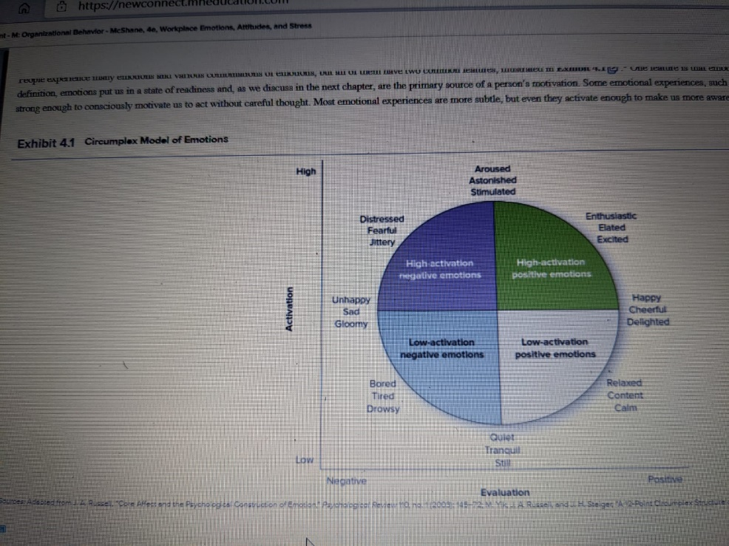

QUESTION 2
Two college graduates recently joined the same major newspaper as journalists. Both work long hours and have tight deadlines for completing their stories. They are under constant pressure to scout out new leads and be the first to report new controversies. One journalist is increasingly fatigued and despondent and has taken several days of sick leave. The other is getting the work done and seems to enjoy the challenges. Use your knowledge of stress to explain why these two journalists are reacting differently to their jobs.

QUESTION 3
- Shanaya is a new manager without experience. Her staff has been highly dissatisfied, which is why the previous manager was dismissed.
a. What would you tell Shanaya about the impact of job satisfaction on performance?
b. Explain to Shanaya four likely outcomes due to job dissatisfaction. (hint: use a model in the text).
c. Discuss four ways Shanaya can increase employee commitment.
d. Shanaya wonders about different types of employee commitment. Explain these to her. Is one of these preferable? Explain.

QUESTION 4
Ruka is having a discussion with her manager Thomas. She is explaining to him that employee satisfaction can lead to greater profitability. Thomas is uncertain. What evidence can Ruka cite to strengthen her argument?
Hint: you need to refer to a specific model in your text.

QUESTION 5
Review your results for the Emotional Intelligence (EI) self-assessment, then please respond to the following:
1. What were your scores for the four areas of EI? For each - do you agree or disagree? Why or why not?
2. Discuss how you can improve your EI.

QUESTION 6
> Think about your experiences recently or in the past. Describe for your classmates one incident in which you were "very stressed" due to each of the following: (i.e. you will identify one situation for each stressor):
- incivility
- work overload
- low task control
> How did you "deal with" (i.e. manage) your stress in each situation? How do you generally manage stress?
> For each - did you also need to engage in emotional labor? Explain

